

**PSP [20ES104] COURSE PROJECT REPORT**

**On**

***“CANTEEN BILLING”***

***Developed By:***

**H.T.NO STUDENT NAME**

***2203A52046 ANANYA .PAGADALA***

***Under the Guidance of***

Mr. Srinivas Aluvala, M.Tech. (Ph.D)

AssistantProfessor

***Submitted to***

Department of Computer Science and Artificial

Intelligence

SR University

Ananthasagar(V), Hasanparthy(M), Hanamkonda(Dist.) – 506371

[www.sru.edu.in](http://www.sru.edu.in/)

**June, 2023**

**DEPARTMENT OF COMPUTER SCIENCE AND**

**ARTIFICIAL INTELLIGENCE**

**CERTIFICATE**

This is to certify that the PSP course project report entitled **“Canteen Billing”** is are cord of bonafide work carried out by the student ***P. Ananya*** bearing roll number ***2203A52046*** of Computer Science and Artificial Intelligence Department during the academic year **2022-23.**

**Supervisor**

**(Srinivas Aluvala)**

**INDEX**

**Sl. No Title Page No**

**1 Problem statement 1**

**2 Module-wise description 2**

**3 Knowledge required to Develop the Project 5**

**4 Source Code (.cfile code) 6**

**5 Results (output) 15**

# PROBLEMSTATEMENT:

# The “CANTEEN BILLING” is a c application developed to store details of the food menu list to the customer, time and date of customer food is ordered on which the list is shown and code of the list.

***By this application Menu list, Sorting, Food item, Continuation of the order and Total bill.***

# MODULES:

In this application all variables and structure are declared globally so that the severable and structure members can be accessed throughout the program at any function call. We can choose any function by using function calls which are declared in switch-case. In order to repeat the loop control statement (do-while) is used with condition.

In this application four modules are used:

1. **Menu list:**

In this module the application asks the person who runs the program to enter n favorite food details. To give customers details for loop is used. In this module there is a menu list is given in program which asks to select the item by using switch case.

1. **Sorting**

In this module sorting of data is done according to the chosen wise.

In this module there is a sub menu which asks to select the sorting wise by using switch case. The sorting submenu will be like press 1 to sort by burgur wise press 2 to sort by French-fries wise press 3 to sort pizza wise press 4 to sort by pasta wise press 5 to sort by pav-bhaji wise press 6 to sort by tandoori paneer wise press 6 to sort egg curry wise press 7 to sort by hyderabadi biryani wise press 8 to sort chicken tandoori. So like that till the list mentioned in the menu continues the food list till wise print 20.

1. ***Food item:***

In this module selection of food item is done according to the chosen wise.

In this module selecting of food item is a sub menu which asks to select the food item by using switch case. The selecting food item it consists quantity, total, GST, Delivery charges, time&date&year.

***4.Continuation of the order:***

In this continuation of the order module and another control statement (dowhile) so that the application asks whether to continue sorting.

1. ***Total bill:***

In this module total bill after the whole program the total bill is shown at the end of the program.

In this module after the selection of food item and the details selected by the customer if he/she wants to continue the order or not after that the total bill of the order is presented to the customer.

1. ***Exit:***

In this module the switch case intimate the user to choose a proper option according to his /her requirements.

**KNOWLEDGE REQUIRED TO DEVELOP THIS APPLICATION**

* + Control Statements (if, if-else, switch)
  + Loop Statements(while/dowhile, for)
  + Functions(Any type of user defined functions)
  + Structure(structures and nested structures)

***SOURCE CODE [.c]:***

***/\****

***COURSE PROJECT TITLE: CANTEEN BILLING***

***------------------------------------***

***DETAILS:***

***NAME:PAGADALA ANANYA***

***HALL TICKET NUMBER:2203A52046***

***YEAR:1st***

***SEMISTER:2nd***

***SECTION:H1***

***--------------------------------------***

***ABSTRACT:***

***-----------------------------------------------------***

***CREATING A PROGRAM BASED ON BILLING SYSTEM OF CANTEEN***

***------------------------------------------------------***

***\*/***

***#include<stdio.h>***

***#include<time.h>***

***#include<stdlib.h>***

***int main()***

***{***

***int c1,a,b,c,d,e,f,g,h,i,j,k,l,m,o,p,q,r,s,t,u,v,w,x,y,z,totalbill=0;***

***int n;***

***struct tm*ptr;***

***time_t t;***

***t=time(NULL);***

***ptr=localtime(&t);***

***h=40;***

***system("COLOR F2");***

***printf("\t\t\t\t----------------------------------");***

***printf("\n\t\t\t\t\tCANTEEN BILLING\t\t\t\n");***

***printf("\t\t\t\t-----------------------------------\n\t\t\t\t\t");***

***printf("\n1.Burger");***

***printf("\n2.French fries");***

***printf("\n3.Pizza");***

***printf("\n4.Pasta");***

***printf("\n5.pav bhaji");***

***printf("\n6.Tandoori paneer");***

***printf("\n7.Egg curry");***

***printf("\n8.hydrabadi biryani");***

***printf("\n9.Chicken Tandoori");***

***printf("\n10.Mutton Korma\t");***

***printf("\n11.Fish Fry");***

***printf("\n12.Chicken Manchurian");***

***printf("\n13.Frankie");***

***printf("\n14.Noodles");***

***printf("\n15.Fried Rice");***

***printf("\n16.Manchow Soup");***

***printf("\n17.Cold Drinks");***

***printf("\n18.Pastry");***

***printf("\n19.Gulab Jamun");***

***printf("\n20.Rasmalai\n\n");***

***do{***

***printf("\nselect your favourite:");***

***scanf("%d",&n);***

***switch(n)***

***{***

***case 1:***

***a=60;***

***printf("burger=%d\n",a);***

***printf("quantity=");***

***scanf("%d",&e);***

***printf("total=%d\n",f=a*e);***

***printf("Gst 18%=%d\n",g=(f+(f*18/100)));***

***printf("dilevery charges=%d\n",h);***

***i=g+h;***

***printf("%s",asctime(ptr));***

***break;***

***case 2:***

***b=40;***

***printf("%s",asctime(ptr));***

***printf("French fries =%d\n",b);***

***printf("quantity=");***

***scanf("%d",&e);***

***printf("total=%d\n",f=b*e);***

***printf("Gst 18%=%d\n",g=(f+(f*18/100)));***

***printf("dilevery charges=%d\n",h);***

***i=g+h;***

***break;***

***case 3:***

***c=100;***

***printf("Pizza=%d\n",c);***

***printf("quantity=");***

***scanf("%d",&e);***

***printf("total=%d\n",f=c*e);***

***printf("Gst 18%=%d\n",g=(f+(f*18/100)));***

***printf("dilevery charges=%d\n",h);***

***i=g+h;***

***printf("%s",asctime(ptr));***

***break;***

***case 4:***

***d=80;***

***printf("Pasta=%d\n",d);***

***printf("quantity=");***

***scanf("%d",&e);***

***printf("total=%d\n",f=d*e);***

***printf("Gst 18%=%d\n",g=(f+(f*18/100)));***

***printf("dilevery charges=%d\n",h);***

***i=g+h;***

***printf("%s",asctime(ptr));***

***break;***

***case 5:***

***j=100;***

***printf("Pav Bhaji=%d\n",j);***

***printf("quantity=");***

***scanf("%d",&e);***

***printf("total=%d\n",f=j*e);***

***printf("Gst 18%=%d\n",g=(f+(f*18/100)));***

***printf("dilevery charges=%d\n",h);***

***i=g+h;***

***printf("%s",asctime(ptr));***

***break;***

***case 6:***

***k=400;***

***printf("Tandoori Paneer=%d\n",k);***

***printf("quantity=");***

***scanf("%d",&e);***

***printf("total=%d\n",f=k*e);***

***printf("Gst 18%=%d\n",g=(f+(f*18/100)));***

***printf("dilevery charges=%d\n",h);***

***i=g+h;***

***printf("%s",asctime(ptr));***

***break;***

***case 7:***

***l=120;***

***printf("Egg Curry=%d\n",l);***

***printf("quantity=");***

***scanf("%d",&e);***

***printf("total=%d\n",f=l*e);***

***printf("Gst 18%=%d\n",g=(f+(f*18/100)));***

***printf("dilevery charges=%d\n",h);***

***i=g+h;***

***printf("%s",asctime(ptr));***

***break;***

***case 8:***

***m=190;***

***printf("Haydrabadi Biryani=%d\n",m);***

***printf("quantity=");***

***scanf("%d",&e);***

***printf("total=%d\n",f=m*e);***

***printf("Gst 18%=%d\n",g=(f+(f*18/100)));***

***printf("dilevery charges=%d\n",h);***

***i=g+h;***

***printf("%s",asctime(ptr));***

***break;***

***case 9:***

***o=500;***

***printf("Chicken Tandoori=%d\n",o);***

***printf("quantity=");***

***scanf("%d",&e);***

***printf("total=%d\n",f=o*e);***

***printf("Gst 18%=%d\n",g=(f+(f*18/100)));***

***printf("dilevery charges=%d\n",h);***

***i=g+h;***

***printf("%s",asctime(ptr));***

***break;***

***case 10:***

***p=600;***

***printf("Mutton Korma=%d\n",p);***

***printf("quantity=");***

***scanf("%d",&e);***

***printf("total=%d\n",f=p*e);***

***printf("Gst 18%=%d\n",g=(f+(f*18/100)));***

***printf("dilevery charges=%d\n",h);***

***i=g+h;***

***printf("%s",asctime(ptr));***

***break;***

***case 11:***

***q=150;***

***printf("Fish Fry=%d\n",q);***

***printf("quantity=");***

***scanf("%d",&e);***

***printf("total=%d\n",f=q*e);***

***printf("Gst 18%=%d\n",g=(f+(f*18/100)));***

***printf("dilevery charges=%d\n",h);***

***i=g+h;***

***printf("%s",asctime(ptr));***

***break;***

***case 12:***

***r=70;***

***printf("Chicken Manchurian=%d\n",r);***

***printf("quantity=");***

***scanf("%d",&e);***

***printf("total=%d\n",f=r*e);***

***printf("Gst 18%=%d\n",g=(f+(f*18/100)));***

***printf("dilevery charges=%d\n",h);***

***i=g+h;***

***printf("%s",asctime(ptr));***

***break;***

***case 13:***

***s=40;***

***printf("Frankie=%d\n",s);***

***printf("quantity=");***

***scanf("%d",&e);***

***printf("total=%d\n",f=s*e);***

***printf("Gst 18%=%d\n",g=(f+(f*18/100)));***

***printf("dilevery charges=%d\n",h);***

***i=g+h;***

***printf("%s",asctime(ptr));***

***break;***

***case 14:***

***T=110;***

***printf("Noodles=%d\n",T);***

***printf("quantity=");***

***scanf("%d",&e);***

***printf("total=%d\n",f=T*e);***

***printf("Gst 18%=%d\n",g=(f+(f*18/100)));***

***printf("dilevery charges=%d\n",h);***

***i=g+h;***

***printf("%s",asctime(ptr));***

***break;***

***case 15:***

***u=80;***

***printf("Fried Rice=%d\n",u);***

***printf("quantity=");***

***scanf("%d",&e);***

***printf("total=%d\n",f=u*e);***

***printf("Gst 18%=%d\n",g=(f+(f*18/100)));***

***printf("dilevery charges=%d\n",h);***

***i=g+h;***

***printf("%s",asctime(ptr));***

***break;***

***case 16:***

***v=190;***

***printf("Manchow Soup=%d\n",v);***

***printf("quantity=");***

***scanf("%d",&e);***

***printf("total=%d\n",f=v*e);***

***printf("Gst 18%=%d\n",g=(f+(f*18/100)));***

***printf("dilevery charges=%d\n",h);***

***i=g+h;***

***printf("%s",asctime(ptr));***

***break;***

***case 17:***

***w=50;***

***printf("Cold Drinks=%d\n",w);***

***printf("quantity=");***

***scanf("%d",&e);***

***printf("total=%d\n",f=w*e);***

***printf("Gst 18%=%d\n",g=(f+(f*18/100)));***

***printf("dilevery charges=%d\n",h);***

***i=g+h;***

***printf("%s",asctime(ptr));***

***break;***

***case 18:***

***x=50;***

***printf("Pastry=%d\n",x);***

***printf("quantity=");***

***scanf("%d",&e);***

***printf("total=%d\n",f=x*e);***

***printf("Gst 18%=%d\n",g=(f+(f*18/100)));***

***printf("dilevery charges=%d\n",h);***

***i=g+h;***

***printf("%s",asctime(ptr));***

***break;***

***case 19:***

***y=25;***

***printf("Gulab Jamun=%d\n",y);***

***printf("quantity=");***

***scanf("%d",&e);***

***printf("total=%d\n",f=y*e);***

***printf("Gst 18%=%d\n",g=(f+(f*18/100)));***

***printf("dilevery charges=%d\n",h);***

***printf("total bill=%d\n",i=g+h);***

***printf("%s",asctime(ptr));***

***break;***

***case 20:***

***z=40;***

***printf("Rasmalai=%d\n",z);***

***printf("quantity=");***

***scanf("%d",&e);***

***printf("total=%d\n",f=z*e);***

***printf("Gst 18%=%d\n",g=(f+(f*18/100)));***

***printf("dilevery charges=%d\n",h);***

***//printf("total bill=%d\n",i=g+h);***

***i=g+h;***

***printf("%s",asctime(ptr));***

***break;***

***}***

***printf("do you wish to continue if yess press 1 else any other number");***

***scanf("%d",&c1);***

***totalbill+=i;***

***printf("total bill=%d",totalbill);***

***}while(c1==1);***

***return 0;***

***}***

***RESULTS(OUTPUT):***

***-------------------------------------------***

***CANTEEN BILLING***

***-------------------------------------------***

1. ***Burger***
2. ***French fries***
3. ***Pizza***
4. ***Pasta***
5. ***Pav- bhaji***
6. ***Tandoori paneer***
7. ***Egg curry***
8. ***HYdrabadi biryani***
9. ***Chicken Tandoori***
10. ***Mutton Korma***
11. ***Fish Fry***
12. ***Chicken Manchurian***
13. ***Frankie***
14. ***Noodles***
15. ***Fried Rice***
16. ***Manchow soup***
17. ***Cold drinks***
18. ***Pastry***
19. ***Gulab Jamun***
20. ***Rasmalai***

***Select your favorites:***

***Mutton Korma=600***

***Quantity=2***

***Total=1200***

***Gst 18 =1416***

***Dilevery charges=40***

***Mon May 22 18:17:48 2023***

***Do you wish to continue if yes press 1 else any other number:1***

***Total bill:1456***

***Select your favorites:12***

***Chicken Manchurian=70***

***Quantity=1***

***Total=70***

***Gst 18= 82***

***Dilevery charges=40***

***Mon May 22 18:17:48 2023***

***Do you wish to continue if yess press 1 else any other number:5***

***Total Bill:1578***

***PROJECT IMPLEMENTATION:***

***MENU LIST WINDOW:***

***This shows the menu list of the canteen favorite items and below that it shows thatselect your favorite: this is how it implements the list.***

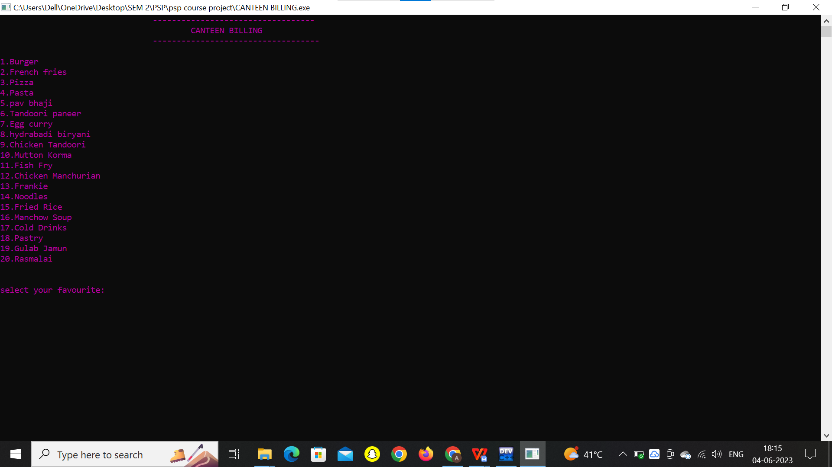

***TAKING THE ORDER:***

***This shows that select the favorites: after this I have choosen 10 according to the list 10 is mutton kurma after choosing it it shows quantity, total, GST, delivery charges, time&date&year as I mentioned in the problem statement.***

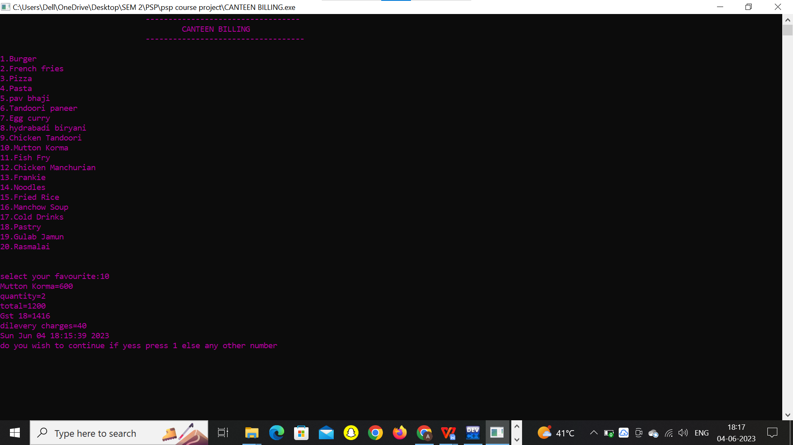

***FINAL OUTPUT OF THE PROGRAM WINDOW:***

***In this output it shows the continue from this statement:***

***DO YOU WISH TO CONTINUE IF YES PRESS 1 ELSE ANY OTHER NUMBER:***

***This statement states that if we want to continue the menu list order then it states that press 1 then it takes another order or if w press any other number like 2,3,4etc… then it stops taking the order and shows the total bill of all the orders.***

